caBIG® Clinical Information Suite
Architecture Team

SOFTWARE ARCHITECTURE DOCUMENT
Final Draft

Table of Contents
1 Introduction 5
2 System Objectives and Considerations 5
3 Approach 6
4 Proposed Architecture 7
4.1 Overview 7
4.2 Components 9
4.2.1 Semantic Adapter 9
4.2.2 Canonical Data Format 13
4.2.3 Integration Platform 15
4.2.4 Clinical Data Warehouse 18
4.3 Orchestration 19
4.3.1 Source clinical system to Integration Platform 19
4.3.2 Integration Platform to Client clinical application 20
5 Security (Working Draft) 23
5.1.1 Patient Consent 23
5.1.2 Restricting Access 23
5.1.3 Securing Transmission between Systems 24
5.1.4 Securing Other Transmission modes 28
5.1.5 Leveraging Security Standards / Technologies 29
5.1.6 Leveraging caGrid 2.0 Prototype 32
6 External Components 34
6.1 Transformation solutions 34
6.1.1 Mirth Connect 34
6.2 XDS solutions 34
6.2.1 OpenExchange 35
6.3 Data warehouse solutions 35
6.3.1 eXist-db 35
7 Reusability 36
7.1 Semantic Adapter 36
7.2 Canonical Data Format 36
7.3 Integration Platform 36
7.4 Transport and Security Layer 37
7.5 Exchange Formats 37
7.6 Data Warehouse 37
8 Assumptions 38
9 Risks 39
10 Appendix A – Service interfaces 40
10.1 Semantic Adapter 40
10.2 Integration Platform 40
10.3 Clinical Data Warehouse 40
11 References 41

DOCUMENT CHANGE HISTORY
Version  Number | Implemented  By | Revision  Date | Approved  By | Approval  Date | Description of  Change
0.1 | Raghu Chintalapati,  Lloyd McKenzie,  David Bass,  George De La Torre,  Jingdong Li,  Satish Patel,  Kunal Modi,  Harsh Marwaha | 4/14/2011 |  |  | Initial draft
0.2 | Kunal Modi, Lloyd McKenzie, Raghu Chintalapati, Harsh Marwaha, Vijay Parmar | 5/24/2011 |  |  | Revised to address updated project use-cases
0.3 | Kunal Modi, Lloyd McKenzie, Raghu Chintalapati, Harsh Marwaha, Vijay Parmar | 6/20/2011 |  |  | Revised to address adjusted scope and use-cases
0.4 | Kunal Modi, Lloyd McKenzie, Raghu Chintalapati, Harsh Marwaha, Vijay Parmar | 6/20/2011 |  |  | Incorporated review comments and updated security section

Introduction
The Software Architecture Document (SAD) is intended to provide an overview of the major software components of the system. It is intended to be used by the software architects, software developers, product managers and anyone who is interested in the high level design/architecture of the software being built. The document provides:

- The organization of the software system
- The selection of structural elements and the interfaces by which the system is composed
- The system behavior, as specified in the collaboration among those elements
- The composition of these elements into progressively larger subsystems
- The architectural style embraced by the software architect that guides the project

In addition, the document is also concerned with usage, functionality, performance, reuse, comprehensibility, technological constraints, and trade-offs.

System Objectives and Considerations
The proposed architecture has been developed with the aim of most efficiently achieving the following objectives and taking into account the outlined considerations.

- Provide a standard-based interoperable solution to allow information from clinical systems (like TRANSCEND) to be shared with other applications. The solution will serve as a general interoperability framework to support information sharing between caCIS clinical and research applications.
- Support ad-hoc queries on a standards-based canonical data repository in which the data can be populated from multiple clinical sources (initially populated by the TRANSCEND).
- Maximize the reusability and uptake of the solution by the oncology HIT communities by leveraging existing standards when possible.
- Allow extensibility to support additional data elements and additional exchange formats as new needs arise.
- Leverage existing open-source components when possible.
- Solution should be production ready and will be deployed into the TRANSCEND production environment as part of the project.
- Leverage design and development artifacts from the prior caCIS project when possible.
- Ensure that all communications and data storage occurs securely and that access to patient-identifiable healthcare information and sensitive clinical research information is secured and limited to appropriately authenticated and authorized applications and users.

Approach
The technical approach is informed by the following strategies:

Design for anticipated changes and reuse

NCI’s full vision for the eventual interoperability and data analysis solution is not achievable in the time and resource constraints for this project. Therefore the solution will be designed to accommodate expected future requirements making it easy to add additional features as needed. Examples include:

- Allowing easy expansion of the set of supported data elements in subsequent iterations
- Address the reuse objectives of the project, making it easy to adapt the proposed solution to other deployment sites
- Defining interface points to allow data integration from multiple sources
- Ensuring technology choices will allow easy introduction of new exchange formats and integration of new clinical systems

Leverage existing standards and off-the-shelf components where possible

Using standards assists several objectives: it reduces project risk by decreasing the amount of custom development and testing; it encourages adoption by clinical system vendors and developers; and it leverages industry expertise, reducing the likelihood if implementation and interoperability issues.

Proposed Architecture

Overview
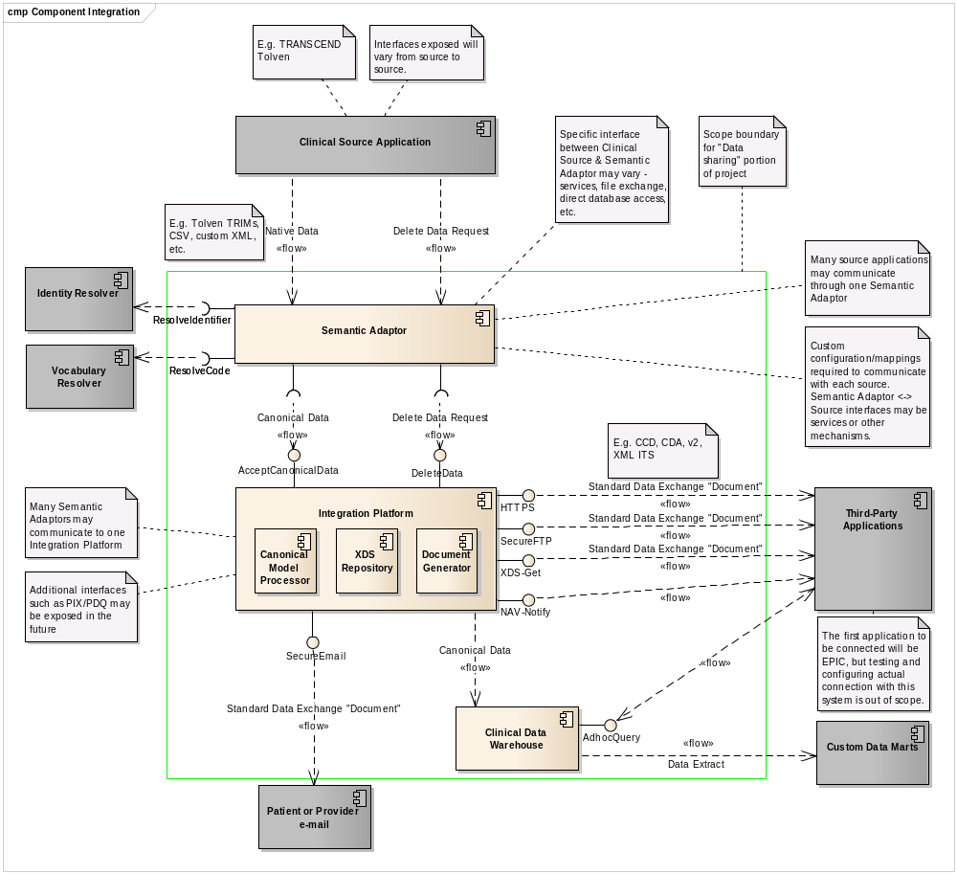
Figure 1 – Conceptual Component Architecture
Figure 1 shows the conceptual component diagram for the generic solution. It identifies what components are proposed to be constructed and how they will interact. Grey represents elements already identified as out-of-scope components. Content within the green box is “in scope”.

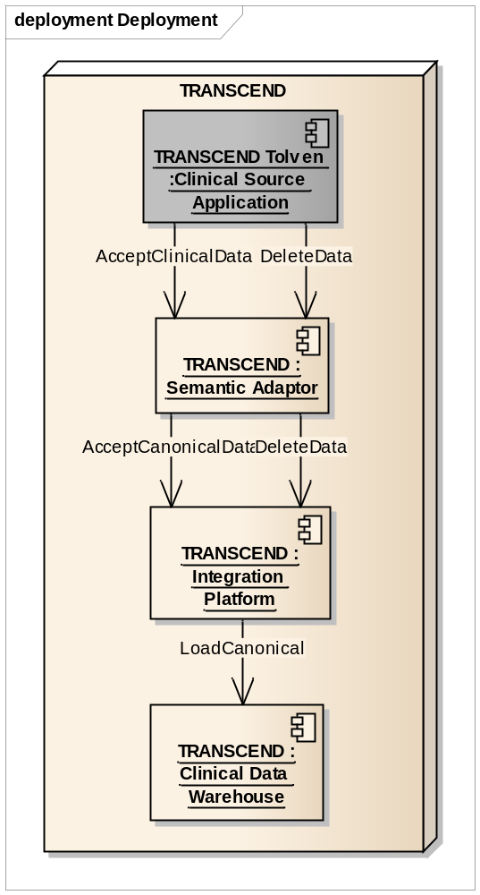
Figure 2 - Conceptual Deployment
Figure 2 shows the component instances that will be deployed as part of this project and the service interfaces that will actually be used within the deployed solution. Those component instances in grey are pre-existing. While changes to the TRANSCEND application will be required to implement the solution, these changes are outside the scope of the work of the project team. Note that most service interfaces that are part of the component definitions but that are not exercised as part of the deployment will still be developed and tested, but the priority of these interfaces will be lower than those required for deployment. Further testing will be required before these interfaces could safely be deployed.

Components
The solution to meet in-scope requirements includes a set of components to be used with the TRANSCEND Tolven instance to allow the standardized sharing of data with other applications to be defined.

The communication/integration portion of the architecture consists of three major components – the Semantic Adapter, the Integration Platform and the Clinical Data Warehouse. For the current project implementation, there will be one instance of each of these. However, in the future, they may be deployed in various configurations as dictated by data sharing requirements. All of the components will share information using a standardized Canonical Data Format.

Semantic Adapter
The Semantic Adapter is responsible for bi-directional data conversion between clinical source applications’ proprietary data formats and the caCIS canonical data format. The semantic adapter is expected to be a reusable component that can be customized to work with any clinical application. This component is an “optional” piece of the architecture in that clinical systems that have the capacity to transform between their native data format and the Canonical format themselves or with the aid of other add-on components will not need to use a Semantic Adaptor.

The current project is scoped to provide an implementation of this adapter, supporting integration with the TRANSCEND Tolven instance. This integration will involve the transformation of a subset of TRANSCEND data exposed as TRIM XML and converting it to Canonical form

This component functions as the “transformation”, “routing” and “integration” part of the overall solution. It is responsible for handling missing data, generating human-readable renderings, performing vocabulary translations and any other clean-up that is needed to expose the clinical application’s data in and consume data from a standardized form. It also manages interaction with external registries to:
- Resolve clinical-application-specific identifiers to common identifiers to allow appropriate data matching; and
- Translate coded values to NCI-preferred code systems.

The above capabilities will be supported by allowing implementers to develop custom-code that addresses the requirements of each deployment site. The adapter will provide a set of general capabilities (support for multiple protocols, service calls, transformation, routing, etc.), that can be extended as needed. The semantic adapter also functions as the component that is responsible for anonymizing data in some cases.

More complex Semantic Adaptors are also possible, capable of pulling data directly from multiple sources and integrating it prior to conversion to canonical. However, such capabilities are outside the scope of the initial implementation.

Clinical source applications will vary widely in both their needs for data manipulation in the conversion between native and canonical, as well as in the communication mechanisms they support for exposing and consuming data. The Semantic Adapter component will have to be highly extendable and configurable to support a wide range of clinical systems as possible. Mirth Connect, the selected product provides the ability to extend and customize using java script and java code.

As the semantic adapter acts like an ESB (enterprise service bus), implementers are not bound to NCI’s choice of the semantic adapter, they can choose a custom integration platform that is acceptable to their enterprise. The caCIS integration platform is loosely coupled with the semantic adapter and this provides the flexibility to “swap” the engine.

The key capabilities of the Semantic Adapter are defined in more detail in the following sections:

Transformation
The Semantic Adapter will provide capabilities to create mappings to and from internal format supported by a clinical system to the Canonical Format required by the integration engine. A key consideration in the selection of the underlying interface engine used by the Semantic Adapter and in the design of the Canonical Format mapped to and from will be making the mapping process as easy as possible for clinical system implementers. Each instance of the Semantic Adapter will require significant configuration to tune it to the local format supported by the clinical application being integrated. The development of the mapping configuration for each Adapter will generally need to be the responsibility of the vendor of that clinical system. However, the project will create the mapping configuration for the two in-scope Tolven instances. The Semantic Adapter will provide clinical system vendors the ability to import and update mappings that are already defined. Clinical system vendors can therefore re-use mappings defined using the Semantic platform, should they also be able to export data in a similar native format.

The Semantic Adapter will make use of off-the-shelf components for both the transformation functionality and for the vocabulary mapping functionality. The interface engine chosen for use in the Semantic Adapter is Mirth Connect. It meets the “free” and “cross-platform” requirements, provides a GUI interface for constructing mappings and is familiar to both the development team and the TRANSCEND team. (See 6.1.1 – Mirth Connect.) The Mirth Exchange (not yet available) platform can be used in future to share transformation mappings to and from the Canonical Format.

NOTE: Due to resource limitations, for the scope of this project, the full set of TRANSCEND TRIM data will not be converted to Canonical. The priority will be to convert all of the TRANSCEND “Clinical Note” TRIMs, supplementing with additional patient-centric outcome data as time allows. The remaining data will be passed in raw TRIM form and will not be available for exchange document construction.

Data push from Source Systems
The Semantic Adapter will expose a simple “AcceptClinicalData” service interface to allow clinical applications to send data for a given patient to the Integration Platform. A simple socket based interface or other interface mechanism could easily be added for interoperating with clinical applications that do not support services. Mirth Connect, the off-the-shelf product under consideration provides out of the box capabilities to interoperate using a number of protocols such as JMS, FTP, HTTP, TCP, LLP, and direct database access.

Identity resolution
Part of the process of converting data to canonical form is the normalization of identifiers. This ensures that patients, providers, study sites, etc. are represented in a consistently for searching, matching and analysis. Such identity resolution can be provided by external registry services that manage mapping of the local or regional identifiers used by clinical systems to the centrally assigned NCI or similar identifier for the object type.

Due to resource constraints, within the scope of this project, identity resolution will be limited to design only. Implementation of identity resolution with the CTRP service or other registries will be deferred to future project phases. Because all data is currently being provided by a single source, the lack of identifier resolution capability should not limit querying capabilities, though updating existing data in the Clinical Data Warehouse with normalized identifiers may be necessary in the future when other systems are brought on stream.

Vocabulary resolution
Converting of data also requires normalizing vocabulary to align with canonical vocabularies, and for ease of querying, possibly also NCI standard terminologies. While vocabulary mappings can be performed by Mirth Connect as part of its transformation capabilities, vocabulary mappings and translations are more ideally provided by a terminology service. The vocabulary resolution interface will allow codes for a given attribute to be translated to a desired target code system via the NCI EVS system or other similar terminology service.

Like the Identity Resolution portion of the solution, the vocabulary resolution interface will be limited to design only. Within the scope of this project, vocabulary translation will be limited to conversion to canonical value sets and will be performed as part of the Mirth Connect transformation process.

Metadata extraction
One of the essential considerations in enforcing security on data shared to other systems and placed into the Clinical Data Warehouse is the value of certain key pieces of metadata, specifically the patient identifier, site identifier and, potentially, the study identifier. These pieces of metadata may be provided directly as part of the data delivered by the clinical source application to the Semantic Adaptor. However, if they are not, the Semantic Adaptor has the responsibility to extract this information from the provided native clinical data for inclusion as part of the data package passed to the Integration Platform.

Data sharing requests
In addition to performing data translation from native to canonical, the Semantic Adapter also acts as a conduit for requests from the underlying clinical application to the Integration Platform to create and share pre-defined “exchange” document versions of content with particular end recipients. No translation is performed on such requests. They are simply passed through the Semantic Adapter for execution. These requests must always be accompanied by the data intended to be used in the construction of the requested document. Data can also be pushed to the Integration Platform without any accompanying publication request if the intention is only to make the data available for export to the Data Warehouse component.

A publication/sharing request contains the following information:
- The type of document to create
- The format(s) in which the document should be created (HL7 v2, XML ITS, etc.)
- Where not already pre-configured within the Integration Platform, the set of systems and/or individuals who are to receive the constructed document and the method and address of delivery (XDS, secure email, etc.)

When data sharing requests are sent to the Integration Platform, errors may be returned if the necessary data is not available to generate the requested exchange format, or if one or more of the identified data recipients are not known. Due to the asynchronous nature of the actual delivery of the data to the intended recipients, errors in the actual delivery process cannot be returned as part of the service call and will instead need to be managed through logging processes. Whether those logs are reviewed in an automated fashion or consulted manually by a technical resource on an intermittent basis will need to be determined by the implementing clinical system.

Canonical Data Format
While not a true “component”, the Canonical Data Format is still a key piece of the architecture. The format provides a standards-based HL7 RIM-derived caCIS data specification into which data from all clinical application data sources will be converted and from which the various standard exchange formats will be generated. The use of this data format is what distinguishes the architecture from being a simple point-to-point integration engine solution. Mapping clinical source data into a common set of data structures helps ensure consistency of data representation and improves data quality for NCI uses.

The Canonical Data Format will be based on a CDA RIM structure of a header together with a number of sections, some required, most optional. The header will be extended to permit capture of Study Identifier and Study Site Identifier data elements in addition to the standard patient identifier where these elements apply. The sections of the document will be of three types: HITSP C32-based CCD, regular CDA and “extended” CDA.

HITSP C32-based CCD: These sections will be used to represent information that is formally defined by the HITSP C32 – Summary Documents Using HL7 Continuity of Care Document (CCD) Component specification. As a required criterion of ONC’s meaningful use final rule, this is the document type that is most likely to be understood by other clinical applications. Where applicable, this standard will be used.

CDA: Some of the data elements which need to be shared are not specified in the HITSP C32 specification but are still expressible as part of regular CDA document. I.e. they can be expressed as part of the clinical statement pattern used for the right-hand-side of the CDA model. While few clinical systems can read arbitrary discrete data from a CDA instance, most can at least understand the human-readable component out-of-the-box. And making custom changes to support data extraction from a particular CDA instance is a process many clinical application vendors are familiar with and are willing to undertake if the discrete data is useful enough. To increase re-use, any CDA sections introduced that are not already defined by CCD will align with other common industry templates such as those created by the American Society of Clinical Oncology (ASCO) and the College of American Pathologists (CAP).

“Extended” CDA: Because CDA R2 limits itself to a constrained model (an older version of Clinical Statement) and a fixed version of the RIM and structural vocabulary, there are some clinical data elements that cannot be expressed within CDA. Additional RIM classes or attributes and/or newer structural vocabulary may be required. The canonical model will capture these within the extended CDA structure, but will add in the additional data elements required as RIM extensions. Within the canonical data representation, these extension elements will be conveyed using a canonical-specific foreign namespace, as per the HL7 XML ITS convention.

There are several benefits to using a CDA-based structure:
- The primary exchange syntax being generated (the one most likely to be understood and supported out-of-the-box by clinical vendors) is CCD
- For all other data elements, CDA’s “human readable” portion provides a base level of interoperability for all data elements
- CDA’s approach of one document with multiple “sections” makes it easy to extend the canonical format in the future by introducing new sections
- CDA uses the RIM as its underlying structure enabling the use of existing templates and data model structures to represent information in a semantically rigorous manner
To reflect the variability of clinical application capabilities and allow for maximum uptake, the canonical data format will treat most data elements as optional unless they are critical for safe data interpretation or minimal delivery of adequate clinical care.

For the overall solution, and in the context of the TRANSCEND implementation, the proposed solution makes “meaningful use requirements” a top priority throughout the mapping and modeling process. The meaningful use final rule requirement (§170.304(i)) requires that CCD and C32 be used to exchange patient summary reports. Whenever a CCD/C32 template exists for mappable data elements, the team intends to use the template for mapping. For data element that have no corresponding CCD/C32 template, we will look into the HL7 published CDA IGs (Historical and Physical report, Consultation note, Operative note, MDS questionnaire IG etc.) and reuse the precedent HL7 CDA IG based template whenever possible.

For data elements that have no corresponding standard CDA IG based template, we will create new CDA templates by reusing precedent CDA template structure and by using meaningful use final rule designated standard vocabularies, ensuring that the template instance will be valid against the normative CDA r2 XSD. When NCI templates are finalized, NCI can promote the template definition to HL7 for ballot, and promote the cancer related templates as HL7 standard template set for nationwide cancer patient data exchange.

Data exports from clinical applications such as TRANSCEND Tolven will be performed in one of two modes:
- Complete exports of all data supported for and capable of validly populating one or more canonical sections. This will include all section data associated with a particular patient (possibly within a particular clinical trial or trial site).
- Partial exports bound to a particular record identifier, such as a referral or discharge summary. In this case the data will be filtered to only include that “relevant” to the associated record. This filtered subset of data will however still be sufficient to produce valid canonical sections.

Note: Merging of canonical sections from multiple source can be performed in the semantic adapter, which will require custom coding (based on each deployment sites requirements) to handle the complexities of merging of canonical sections. No merging of canonical sections will be performed within the scope of this project, as TRANSCEND data will come from a single source and will already reflect “current” data. The complexity of the clinical logic required to safely integrating the sections without excluding essential content, including inappropriate duplicate content, altering clinical interpretation, and maintaining accurate human-readable representation of the content, and anticipating the different variations makes an automated merging capability un-implementable. However this capability can always be implemented by the source systems, or by developing custom code in the semantic adapter.

The canonical model categorizes its attributes in the following three categories:
- Identifiable attributes – These attributes contain patient-identifiable information
- Anonymized attributes – These attributes can contain identifiable information (e.g. MRI reports, Pathology Reports). The source system or its Semantic Adapter is responsible for ensuring that such attributes never contain any identifiable information.
- De-Identified attributes – These attributes cannot contain identifiable information
This classification of attributes is done to inform the source systems as to the expectations for population of data elements. Adherence to these rules is essential if the Data Warehouse is to eventually permit public access to de-identified and anonymized data through the creation of an appropriate data mart. The source system is responsible for ensuring that patient identifiable information is passed only in the attributes (of the canonical model) marked as “Identifiable attributes”. Passing patient identifiable information in any other attributes will result in it being exposed even in de-identified exports.

Integration Platform
The Integration Platform provides a secure interface that makes clinical patient data available to the authorized applications and individuals. It provides a “system integration” layer allowing a clinical system to share its clinical information with many other systems. It is responsible for consuming Canonical data from a given source (or with an integrating Semantic Adaptor, data from multiple sources), and transforming the data into a format that can be consumed by one or more receivers. It also manages the exchange of information in a secure form, ensuring authentication of the systems or users involved.

Like the Semantic Adapter to clinical source, there will be a set of simple service interface that allows the Semantic Adapter to pass data to the Integration. The external interface by which that data is accessed by other clinical applications is described below in section 4.2.3.3.

The Integration Platform includes a number of other functions, including validating canonical data extracted from clinical systems, assembly of information into standardized formats (CCD, CDA, HL7 v2, etc.) for exchange and managing the exchange of that content with other systems, including authentication and authorization. Details of some of these capabilities are covered in the following sections.

Validation (Section is in a Working Draft)
Some degree of validation of the data provided by a source application to the Integration Platform is essential to ensure that shared information is “safe” for clinical use. Because the data will be transformed into a variety of formats, it is essential that the content meet certain minimal requirements prior to transformation. This validation is in addition to the validation performed by the semantic adapter, these are additional rules that can be specified (as needed) to ensure that the generated document meets the IG specifications for that document type.

In addition to XML schema, expectations for document content will be enforced through the use of Schematron rules validation. These rules can be easily enforced using XSLT in a cross-platform manner. The rules will be produced in an automated fashion through the use of Templated CDA tools that will also be used to create the CDA implementation guides.

Publication Assembly
This is the process by which the Canonical Data Format is transformed into one of the public exchange formats – CCD, CDA, and RIM XML or HL7 v2. This function shares the same requirements as the Semantic Adapter component – it needs to be able to transform and filter data and possibly translate coded data. The main difference is that the transformations are stable, because the use of the Canonical Data Format insulates the publication assembly process from the variations in the data organization of the various participating clinical applications.

Because of the similarity of requirements, the architecture will re-use the same engine for transformations, as selected for use in the Semantic Adapter. This simplifies deployment and minimizes learning curve while delivering all needed functionality. For simple transformations (such as filtering the canonical form to just CCD or just CDA, the architecture team will examine the possibility of just using XSLT, as this may be even faster than using the mapping functions of the interface engine.

Introducing new publication formats will be a simple matter of developing the necessary mapping profile and adding it to the configuration information for the tool.

Content exchange
This is the process by which clinical applications request delivery of a particular formatted publication of a particular patient’s data. It also represents the process by which data can be “pushed” to other clinical applications in situations where that’s the desired application behavior.

For clinical source-initiated data retrieval from the Integration Platform, there’s already a widely adopted IHE Cross-enterprise Document Sharing (XDS) standard that allows retrieval and storage of documents, v2 message structures and similar data constructs. This standard is web services based and meets the requirements for data exchange. Because it is already widely adopted, it increases the likelihood of broader uptake for the artifacts for this project. There are already open-source XDS solutions available that we can leverage rather than building our own secure communication mechanism.

For most “pushed” data sent to systems, the project will leverage IHE’s Notification of Document Availability (NAV) standard to inform a recipient that a document exists. The recipient will then execute a standard XDS Get to retrieve the document and will then initiate their local import process. (In the case of the caCIS PCO environment, this will mean transforming to canonical and invoking the Semantic Adapter to convert the data to PCO TRIM and invoke the Transcend import process.)

The rationale for this two-phase “push” is that it avoids any assumptions about the recipient application’s network location or availability and gives the recipient application the ability to process received documents as appropriate for its own workflow (via user intervention, off-hours batch load or some other mechanism). It also leverages industry standards and provides for consistent behaviors in both “push” (notification) and “pull” (query) modes of operation, should the latter mode be desired in the future.

In addition to this standard system-to-system push interface, a simple secure FTP interface will also be made available for applications not capable of implementing web services. A secure email interface will be provided for circumstances where an exchange format (likely a CDA document) needs to be made available directly to a healthcare provider or patient outside of a particular clinical application. Finally, a HTTPS interface allowing direct data delivery as an HTTP payload will also be supported.

Authentication and Audit
IHE provides a companion standard for XDS called ATNA (Audit Trail and Node Authentication). This profile is also widely supported and meets the project requirements for authentication of the two communicating nodes, secure communication and auditing of the exchanges that have taken place. Rather than introducing protocols that are unfamiliar to clinical vendors, it makes sense to leverage existing standards that have already been incorporated into off-the-shelf standards.

Because the NAV notification doesn’t contain any patient-specific information (only a document id, the source application and the target application), authentication and encryption are unnecessary for this portion.

Patient Registry
A patient registry is not strictly required for the in-scope functionality for this project. However, patient registry services may become important in future versions of the application where data integration will be required or where there will be multiple clients for the Integration Platform. For this reason, the existing Client Registry functionality will be retained as part of the Integration Platform functionality. Time allowing, the Client Registry function could be upgraded to expose the PIX/PDQ (Patient Identifier Cross-reference and Patient Demographic Query) interfaces to allow broader and easier uptake by the clinical system vendor community.

Clinical Data Warehouse
The Clinical Data Warehouse provides a mechanism for collecting data from one or more Integration Platforms and making it available for complex ad hoc querying and analysis. This platform allows for more complex manipulations than can be performed in the document generation interface of the Integration Platform such as queries that span trials or patients. More importantly, it supports the execution of ad-hoc queries to answer one-off questions that are ill-suited to an XDS interface.

The Clinical Data Warehouse is maintained separately from the Integration Platform in part to isolate the Integration Platform from the performance risks associated with execution of ad-hoc queries. It also aligns the NCI architecture with good design principles for data warehouse type solutions. Note that the warehouse is limited to querying against the data it has been provided by source systems. It is not able to supplement its available data in real-time to respond to a query. Given the ad-hoc nature of the queries performed, this would have presented extreme and possibly insurmountable technical challenges.

The data warehouse will most likely be implemented as an XML Database and will support queries formulated using the XQuery language. It will be possible to filter on any of the canonical data elements both in terms of the columns returned and the rows exposed, though limitations may be experienced based on a user’s security privileges around access to particular patients, sites or studies. See the security below for further details. Furthermore, more sophisticated analysis mechanisms such as averaging, counts, etc. can be introduced.

Because not all TRANSCEND data is being converted to Canonical format within the scope of this project, the original TRIM source data will also be persisted in the data warehouse repository. This original source data will retain its original syntax and organization and will include both data elements that have been converted to Canonical and those that have not. In theory, this data can also be queried via the ad-hoc query interface. More importantly, it is available for eventual conversion to canonical format when project resources allow the translation of additional data elements.

Because the Clinical Data Warehouse is intended to support absolutely any possible query, and the specific types of queries are difficult to predict, rigorous tuning and optimization of the data store will not be possible. As well, the volume of data within the warehouse will grow extremely large over time. For this reason, the warehouse will provide an extract interface permitting subsets of data to be copied from the warehouse into smaller data-mart solutions that are custom tuned to answer more narrow questions, and can be optimized for performance/analysis. Because of their tuning and optimization for a limited data set, queries performed against these data marts will likely be more efficient.

The data warehouse will not support querying by users who only have permission to access de-identified data. De-identification will require additional transformation to trim date information, generalize geographic information and perform other transformations. As well, safe de-identified access requires a degree of data and source de-identification process verification that cannot be achieved within the scope of this project. De-identified queries will best be managed through the creation of a separate data mart intended only for that purpose. The necessary transformations and filtering can be performed as part of the creation of that data mart.

Orchestration
The scope of this project is limited to one primary communication pattern that needs to be supported by the architecture solution: Source clinical application export pushed to consumer clinical application for direct import.

Within this communication patterns, there are two communication steps. The first is between the source clinical application and the Integration Platform via the Semantic Adapter. The second is between the Integration Platform and the consuming clinical application.

Source clinical system to Integration Platform
The first step – source clinical or research system to Integration Platform – will always happen in the same way. Communication will be initiated from the source clinical system for the data it wishes to share. This data will be pushed across the Semantic Adapter into the Integration Platform. The specific timing of the push of data may vary from application to application. It could be done in real-time as data is updated in a patient record, or it could be handled as an off-hours upload.

There are several reasons for adopting a “push” model from the source clinical application and introducing a data storage requirement for the Integration Platform:
- There is no standard mechanism for clinical system vendors to process real-time requests for data and few clinical applications have that capability. Introducing such a mechanism adds considerable complexity to the clinical application that vendors may be reluctant to undertake
- The performance characteristic of data retrieval from some clinical applications is likely to be poor. When the time needed to transform the data to canonical form is added, not to mention the time to retrieve and integrate data from multiple data sources, a real-time retrieval approach becomes extremely hard to do in the time demanded by an inbound query with a clinician waiting on the other end.
- Having a data store within the Integration Platform removes the “load” of needing to respond to real-time query requests from the clinical application. All the clinical application needs to do is push out the data once each time it changes. It doesn’t need to deal with the 10s or 100s of times that particular record might subsequently be queried.
- Not all clinical applications have 24x7x365 availability. Offloading the data sharing responsibility to a separate component reduces risks of needed data being temporarily unavailable.
- The approach of data sources pushing information into a data repository is aligned with the architecture supported by the XDS specification.

Integration Platform to Client clinical application
This “push” mode will be used for passing data from the TRANSCEND Tolven instance to other clinical systems such as EPIC. In this mode, the steps will be as follows:
- This process is triggered when a request to accept canonical data is received from a clinical application.
- If document generation instructions are included with the request:
  - A list of target recipients and required output format(s) for each recipient is determined from the recipients identified as part of the clinical to Integration Platform service call.
  - The Integration Platform determines the security credentials for the intended recipient and identifies whether those recipients are allowed to receive the document based on the document metadata. If the answer is “no” for any of the recipients, the process aborts and an error is returned. Otherwise continue.
  - The Integration Platform checks whether it has the necessary data to construct the requested exchange document type.
  - If not, it returns an error and aborts the process. Otherwise continue.
  - The Integration Platform executes the necessary transforms to generate each of the requested document formats
  - The Integration Platform validates that the generated documents are valid against the profile for the specified format, if any.
  - If there were errors generating the content or in the validation, the process aborts and error messages are returned to the clinical system. Otherwise continue.
  - For all non-XDS delivery mechanisms (FTP, e-mail, etc.), the Integration Platform delivers the requested document formats to the intended recipients. If there are any errors with the delivery process, those are logged and are not returned to the user.
  - If one of the intended delivery mechanisms is XDS
    - The Integration Platform stores the XDS-deliverable documents in the XDS repository
    - The Integration Platform sends a NAV “Notification of Document Availability” to each target application with the identifier for the XDS-stored document.
    - At some point later (outside this process cycle) when convenient, the consumer application invokes the “Get Document” service on the Integration Platform to retrieve the identified document.
- The Integration Platform sends the Canonical data to the Clinical Data Warehouse.
- If there are any issues, a message is returned to the requesting system indicating that the data was not properly persisted in the warehouse but that any requested documents had their delivery successfully initiated.

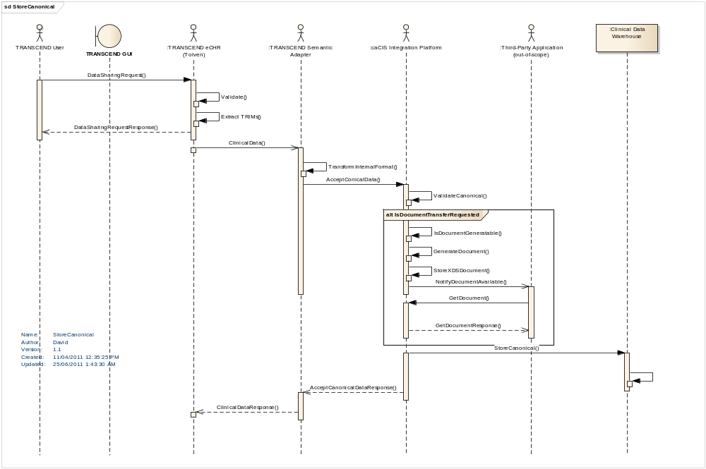
Figure 3 - TRANSCEND interactions

Security (Working Draft)

Since this integration effort deals with Patient Identifiable Information (PII) and Protected Health Information (PHI), security of the data becomes of prime importance. Also, due to the nature of the data, it falls under various federal regulations and policies such as HIPAA (Health Insurance Portability and Accountability Act), HITECH (Health Information Technology for Economic and Clinical Health) Act.

Security in this context encompasses concerns such as:

Patient Consent
HIPAA requires a medical provider to obtain a patient’s consent before their medical information can be shared with another medical provider. This is generally obtained before beginning of any treatment or, in case of a clinical trial, at the time of enrollment into a study. This is a patient centric activity and is generally carried out in field by the medical provider or their assistants.

As part of this integration architecture, obtaining or ensuring a patient’s consent is out of scope. Front end applications such as TRANSCEND’s Tolven which is used to register subject onto the I-SPY2 trial will be responsible for obtaining all the necessary consent as part of the registration process. These include consent to transmit the document to trading partner as well as to make data available for research and analysis in both secured and de-identified manner. The integration architecture does not perform any sort of checks to verify if the consent is obtained or present. This is mainly for the reason that each of the front end clinical application (in TRANSCEND’s case Tolven) handle and store this consent in a different manner.

Restricting Access
The HIPAA privacy law specifies that access to a patient’s medical record should be restricted and be available only to authorized users. This implies that the systems which store and present patient data to users should have security mechanism to ensure that only authorized users are allowed access to patient medical records. This is generally achieved by the combination of Authentication and Authorization mechanisms which not only establish who the user is but also control their access privileges.

Since authenticating an end user and checking their access privileges is a function of the front end systems (in this case TRANSCEND’s Tolven eCHR), they are out of scope of the current integration work.

Securing Transmission between Systems
As this architecture deals with effective transmission of Patient Centric Outcomes as well as Clinical Notes data across the enterprise, securing transmission of PII and PHI is of prime concern from a security perspective. Security in this context includes ensuring that only the intended recipient receives data, that the source of the data is a trusted source, that no third party has access to the transmitted data, and that the data cannot be manipulated between sender and receiver without detection.

There are various points of communication in the proposed architecture and following sections describes the security implied at each of such communication points

Between a Clinical Application and the Semantic Adapter
There can be cases where a single semantic Adapter is hosted commonly between multiple clinical applications. It is recommended to secure such transmissions even though they might occur within the realm of secured network in a given single organization. It can follow the node to node mutual authentication pattern recommended as part of IHE’s ATNA profile mentioned below.

The mutual authentication is established using X.509 digital certificates. A trust is established between the clinical application and the corresponding semantic Adapter by registering each other's public key. Then the communication channel between them is secured using Transport Layer technology such as SSL. This was only trusted clinical applications are able to communicate with the semantic Adapter. Also as the transport channel is encrypted and secured no one else is able to read or understand the messages exchanged between them.

Supports:
- Optional Transport Layer Security

Between the Semantic Adapter and the Integration Platform
A single Integration Platform can accept inputs from multiple semantic Adapters. These semantic Adapters can be from a single organization or spread across multiple organizations (e.g. in case of a multi-site trial). In such scenarios the communication channel needs to be protected. This channel will also be secured using the same node to node mutual authentication pattern recommended as part of IHE’s ATNA profile mentioned below.

As mentioned above it will also leverage the X.509 digital certificates to establish a trusted and encrypted communication channel between the semantic Adapters and integration platform.
Optionally, this channel can also employ authorization at the integration platform inbound interface (Accept Canonical) to restrict access to only trusted and allowed Semantic Adapters. This authorization component leverages the digital certificates used to secure the communication channel to obtain the identity of the communicating semantic Adapter node. It can be developed as an HTTP filter (or a PEP/PDP pair) which intercepts the incoming request and retrieves the identity of the peer (i.e. the Semantic Adapter trying to communicate with it). It can then check if the Semantic Adapter is authorized to communicate with integration platform. If granted access then it will accept the request from the Semantic Adapter and cater to it.

This authorization feature is useful if the integration platform is hosted centrally (e.g. at NCI) and trust is established by trusting the issue certificate authority directly rather than individual certificates (in this case the integration platform will trust all the certificates issued by the certificate authority, however the access is restricted by employing an authorization component).

Supports:
- Transport Layer Security
- Optional System Level Authorization

Between the Integration Platform and other Integration Platforms or Client Clinical Application
The integration platform can expose the clinical data it has obtained from various source clinical systems via two interfaces, Document Transfer Interface and the Query Interface. Both of these interfaces need to be secured. The following sub section provides details on how these interfaces are secured.

XDS based Document Transfer Interface
This interface allows recipients to query for and retrieve documents from the underlying XDS store in the Integration Platform. Since these documents contain PII and PHI, the interface needs to be secured. This interface is also secured at transport level using IHE’s ATNA profile which leverage X.509 certificates to establish mutual authentication. The trading Integration Platform or the Client Application communicates to the query interface by using its own certificate to establish a secured communication channel.

Authorization
An authorization component is employed at this interface which will ensure if the recipient has access at the following granular levels
- Study Level Access – Has access to all data for a given study
- Site Level Access – Has access to all data for a particular site for a given study
- Study Subject (Patient) Level Access – Has access to only data for a particular study subject (patient)

The authorization component can be similar to the one used on the inbound side of the integration platform. It can be an HTTP filter which acts like a Policy Enforcement Point (PEP) which can retrieve the identity of the recipient from certificates used to secure the channel. It can then pass this identity along with the study / site / study subject information to a Policy Decision Points (PDPs) which will assert if the user has the required access privileges or not. These PDPs can employ authorization technologies such as XACML or even leverage Common Security Module (CSM) to house authorization policies for each recipient. They will look up these authorization stores and determine if the user has access to the requested data (document) or not.

The provisioning of the user’s policy is a responsibility of the Integration Platform’s administrator. However, if there are any existing authorization policy stores available (e.g. such with the source system or centrally hosted authorization policy stores such as caGrid’s Grid Grouper) then they can be plugged into the integration platform as an authorization PDP. This removes the requirement to separately provision the user.

User Level Access
It is recommended that the document transfer occur between two secured nodes as dictated by ATNA, However, if an end user needs to be retrieve documents (via an application or a custom client written) then can do so in similar fashion as a node. In this case the end users will provide an X.509 digital certificate to identify themselves to the integration platform. Integration platform will then use the identity from the certificate to check if the user is authorized and return the requested documents accordingly

Supports:
- Transport Layer Security
- Optional Authorization at Study, Site or Study Subject level
- Optional User Level Access

Query Interface
The query interface provides capabilities to retrieve data from the clinical warehouse. This interface supports ad-hoc querying by end users. This interface is exposed directly by the clinical warehousing solution/product to be used which will most likely be eXist. eXist provides various standard querying interfaces such as HTTP REST, SOAP, XML RPC, WebDAV, Atom RSS, XML DB APIs. All of these interfaces can be used by end user for querying data out of eXist database.

eXist also comes with its own user authenticating and provisioning mechanism. Alternatively eXist can plug into existing LDAP based credential providers to leverage existing users which are provisioned there.

All the interfaces of eXist-db require users to provide their user name and password in order to connect to the database. This is extremely desirable as it provides a standard way for user to query and retrieve data from any of the interfaces. Based on whether these credentials are provisioned locally or externally, eXist validates these credentials in order to authenticate the user and allow access to the database.

Also all interfaces of eXist (mainly HTTP based) will be secured using X.509 digital certificates at transport level. This adds the transport level security and encrypts the transmission channel.

Also eXist comes with its own in-built authorization security. This authorization works in conjunction with eXist’s authentication. User identity which is used for authentication is also leveraged for authorization. eXist also allows creation of user groups. This is also a very desirable feature as it allows grouping of users into various group and then provisioning access control at group level. This eliminates the needs to provision authorization for each and every user.

As eXist is an XML based solution it stores all the data in form of XML documents. These documents are arranged in collections. Both XML Documents and Collections are considered as resources and access to them can be controlled by applying authorization. This feature can be leveraged to provide the study, site and patient level granularity that is required for the warehouse. A collection can be created for each and every study, site and subject. Since this won’t be known till run time the ETL process which loads the data into the warehouse can be tweaked to create collections every time a new study, site or patient is encountered. Now the incoming xml document which contains the clinical data can be added to the appropriate study, site and patient collections.

Now authorization policy can be provisioned which grants users (or user groups) access to these collections there by effectively providing study, site and patient level granular access control.

De-identified Data via the Query Interface
It would be very risky to allow adhoc query on a database which contains identified information and relies on filtering capabilities to mask identified attributes. Advanced users can trigger various permutation combinations in their queries via which they can effectively determine who the patient is.

So in order to mitigate this risk, the architecture team advises creation of a separate de-identified data mart. This data mart can be periodically populated from the data sitting in the warehouse. Various algorithms can be applied during this population process to make sure that the data is completely and properly pseudonymised. Also quality checks and be enforced to make sure that the data that is contained in the data mart doesn’t contain any identifiable information in any other attributes. Now this data mart can be hosted separately in an unsecured fashion thereby allowing any researchers to query the data and perform their analysis.

Also a process needs to be established which determines when a study’s data can be made public and exposed in a de-identified manner to the rest of the researchers. As a general rule, all the data within a study should be secured till the study is active. Upon closure of the study, the data can be redacted and made available for consumption by other researchers.

Supports:
- Transport Layer Security
- User Level Access
- Authorization at Study, Site or Study Subject level
- De-identified data for anonymous queries

Securing Other Transmission modes
Apart from the document interface, the integration platform is also capable of transferring documents via email or as a file transfer directly to a recipient. As both of these modes will contain documents that contain PII and PHI they need to be secured as well. The following sub section provides details on how these modes of transport will be secured.

Secured Email
The Integration Platform will transmit the generated documents securely to the recipients using secured mail protocols such as S/MIME. A Secure email transmission involves the following two components
- Encryption: The content of the message is encrypted using the recipient’s Public Key (from X.509 certificate). This ensures that no one other than the recipient can access the content of the message
- Signing: The email itself is signed by the sender’s private key and the signature must include the signing certificate and the full certificate chain up to the root CA. This allows the recipient to verify who the originator of the email was and thus authenticate the sender

IHE provides the Cross-Enterprise Document Media Interchange (XDM) profile, which allows transmission of documents as email attachments. Since XDM supports the same document content as XDS, it can be stood up in parallel to the current XDS repository to transmit documents to the registered recipient.

This provides Message Level Security by encrypting the entire content of the message such that the un-trusted intermediaries cannot access the data.

A major challenge for such transmission is to:
- Ensure that all the senders and recipients have digital certificates which are necessary for encryption and signing of secured emails. These certificates can be provided by respective institutes or centrally by NCI.
NOTE: These certificates should be long term certificates
- Employ a mechanism for the sender to obtain the recipient’s certificates in order to encrypt the message.

Secured File Transfer
The Integration Platform will also be able to transmit the generated documents generated securely to the recipients using a file transfer mechanism. This file transfer will be over a secured communication channel and will employ digital certificates to secure the channel. It can leverage existing secure file transfer protocols such as SFTP.

Audit
A key aspect of data security and of some privacy legislation is the ability to audit what information was shared and with whom. This is also a required aspect for this project. The integration platform will be capture audit logs for each of the transaction that occurs within itself. These include the inbound transmissions of data or document generation requests as well as outbound querying/retrieval of documents or data. It will capture the identity of the trading party (sender or recipient) along with their actions, timestamps and relevant data as part of the audit logs.

Leveraging Security Standards / Technologies
To ease integration with existing clinical applications, security requirements will be met by leveraging IHE (Integrating the Healthcare Enterprise) profiles that have been widely adopted in this space. These profiles provide details about how security can be achieved in an integrated health enterprise, in particular when using other IHE standards such as XDS.

IHE provides a companion standard for XDS called ATNA (Audit Trail and Node Authentication). This profile is also widely supported and meets the project requirements for authentication of the two communicating nodes, secure communication and auditing of the exchanges that have taken place. Rather than introducing protocols that are unfamiliar to HER clinical vendors, it makes sense to leverage existing standards that have already been incorporated into off-the-shelf standards.

Because the NAV notification doesn’t contain any patient-specific information (only a document id, the source application and the target application), authentication and encryption are unnecessary for this portion.

Audit Trail and Node Authentication (ATNA) Profile
The Audit Trail and Node Authentication (ATNA) Integration Profile establishes security measures which, together with the security policy and procedures provide patient information confidentiality, data integrity and user accountability when data is transmitted between systems. ATNA contributes to access control by limiting network access between nodes and limiting access to each node to authorized users. Network communications between secure nodes in a secure domain are restricted to only other secure nodes in that domain. Secure nodes limit access to authorized users as specified by the local authentication and access control policies.

ATNA profile addresses three areas of security in an enterprise:
- User Authentication: The ATNA profile requires only local user authentication, thereby allowing the each of the secured nodes (e.g. TRANSCEND’s eCHR, institute’s EPIC system) to use the access control technology of its choice to authenticate users.

- Connection Authentication: The ATNA profile requires the use of bi-directional certificate-based node authentication for connections to and from each node. The DICOM, HL7, and HTML protocols all have certificate-based authentication mechanisms defined. These authenticate the nodes, rather than the user. This profile relies on the WS-I Basic Security Profile 1.1 for Web Service security.

- Audit Trail: The ATNA profile ensures user accountability via audit trails. It allows administrators to:
  - Assess compliance with a secure domain’s policies
  - Detect instances of non-compliant behavior
  - Facilitate the detection of improper creation, access, modification and deletion of Protected Health Information (PHI)
ATNA not only deals with creation and storage of Audit records but also transmission of Audit records across the enterprise using the Syslog Protocol. Since the integration architecture has no requirement of making audit trail available across the enterprise, the caCIS Integration solution will not implement the Audit Trail sharing portion of the ATNA profile.

Connection Authentication implies establishing mutual authentication between various components of the integration architecture. This implies securing the connection between the HER clinical system and the semantic adapter using HTTPS as well as between the semantic adapter and the integration platform. On the other end, the outbound channels from the integration platform will be secured using HTTPS as well. Securing these interfaces will require use of digital certificates.

Consistent Time (CT) Profile
The Consistent Time Integration Profile (CT) provides a means to ensure that the system clocks and time stamps of the many computers in a network are well synchronized. This profile specifies synchronization with a median error less than 1 second. This is sufficient for most purposes. Various infrastructure, security, and other profiles require use of a consistent time base on multiple computers, to synchronize logs, authenticate users or nodes (using their digital certificates), digitally sign documents, etc. The Consistent Time profile requires the use of the Network Time Protocol (NTP) which is supported by most of the operating systems.

Since the integration architecture relies on use of digital certificates to mutually authenticate the nodes, it will require that all the systems that participate in the integration be synched with a common time service such as time.nist.gov. A detailed list of servers can be obtained from http://tf.nist.gov/tf-cgi/servers.cgi.

Other Profiles
IHE provides two additional profiles which deal with User Authentication and Authorization:
- Enterprise User Authentication (EUA) Integration Profile defines a means to establish one name per user that can then be used on all of the devices and software that participate in this integration profile.
- Cross-Enterprise User Assertion Profile (XUA) - provides a means to communicate claims about the identity of an authenticated principal (user, application, system...) in transactions that cross enterprise boundaries.

However, since the end user authentication is out of the scope, these profiles are no relevance to the integration architecture.

Level of Assurance (LOA)
NIST’s E-Authentication Guidelines on Level of Assurance (LOA) for a user’s (or a system’s) identity provides guidelines on the minimal LOA that needs to be established depending upon the type of data access or transmitted. Since we are dealing with PHI/PII as part of this integration, the minimal level of assurance should be LOA2 or 3.

Digital Certificates and Certificate Authorities

The integration architecture uses digital certificates to identify the recipient node or possibly the end user. Digital certificates are also used for secure email as well as secure file transfers. The use of digital certificates satisfies the two-factor authentication requirement of the LOA3 guideline.

A certificate authority is needed which can provide such digital certificates to the nodes or end users. Also the certificate authority should be able to ensure the minimal level of assurance stated in the section above.

NCI’s caGrid runs its own Certificate Authority (CA) called Dorian which is capable of issuing long term (1 year) certificates for the nodes or short term certificates for end users. However this CA is not certified and operates at a lower level of assurance. This means that anyone can obtain certificates from this CA without any elaborate vetting process and participate in the architecture. This is not acceptable for the proposed caEHR caCIS solution because the architecture deals with transmission of PHI.

The other options are to obtain certificates from third party entities such as Verisign, ETrust etc. They have a defined identity vetting process which can map to a higher LOA such as LOA-3. Alternatively, the system administrators can choose to generate their own certificates on the servers. In either case, trust needs to be established between the participating nodes. This is achieved by adding the public certificate of the other party (or if the certificates are obtained from a CA, then CA’s public certificate) in the node’s trust store.

Leveraging caGrid 2.0 Prototype

caGrid 2.0 PST Prototype is used primarily to issue secure tokens which assert user’s identity once they have been authenticated locally. This is primarily useful when you need to assert users identity across an enterprise. This is compliant with IHE’s Cross-Enterprise User Assertion (XUA) profile. XUA provides a means to communicate claims about the identity of an authenticated principal (user, application, system) in transactions that cross enterprise boundaries. It defines the following three actors: X-Assertion Provider, X-Service User and X-Service Provider
caGrid’s STS fit the XUA profile completely. The STS server is X-Assertion Provider and generates SAML assertion tokens. These SAML assertions are signed by the STS to ensure that they cannot be tampered with. Since X-Service Provider trusts the STS (established via WS-Trust) it will honor these assertions and cater to the request of the X-Service User.

Possible Solution using caGrid 2.0
caGrid 2.0 STS server will be leveraged to issue SAML Tokens. An IdP will be developed that wraps Tolven’s OpenLDAP to authenticate users. Trust needs to be established between the XDS server and STS so that it can honor the assertion created by it. Alternatively, a Node-level user can be configured which represents the Integration Platform (IP) into Tolven’s OpenLDAP. An assertion can be obtained for this user by passing the credentials directly at the Integration Platform level. Once the SAML Assertion is available, the Integration Platform can embed it as a Token in the SOAP header and pass it as part of the query to the XDS server on the TRANSCEND side on behalf of the user.
The XDS interface will retrieve the SAML assertion and validate its signature against the one configured for the STS. Since XDS server trusts STS, it will be able to ensure that the assertions about user’s identity are valid and it will successfully authenticate the user and serve the request.

Issues in leveraging caGrid 2.0
- caGrid 2.0 prototype needs to be fortified to a production level code with adequate testing and documentation
- Creation of solution at individual user level (User of Tolven) will require elaborate changes to Tolven as well as to the caGrid 2.0 prototype

External Components
This section describes the open-source components presently being considered for inclusion as part of the solution. Decision documents evaluating alternative solutions have been created for several of these components and have undergone review by NCI, the development and test teams.

Transformation solutions

Mirth Connect
Mirth Connect is an open source standards based healthcare interface engine. Mirth Connect facilitates routing, filtering and transformation of messages between health information systems. Mirth Connect provides an easy to use graphical administrative user interface that can be used to define routing, filtering and transformation of messages. Mirth Connect integration interfaces and transformation capabilities can potentially be used for integration with Transcend and PCO Tolven instances.

Mirth Connect supports a variety of protocols and integration interfaces including: LLP (Lower Layered Protocol), SOAP, JMS, FTP, File, HTTP, TCP and Database. It provides transformation support for messages based on a number standards including: HL7 v2, HL7 v3, XML, DICOM (Digital Imaging and Communication in Medicine), NCPDP (National Council for Prescription Drug Programs), EDI (Electronic Data Interchange), X12 and Delimited Text

Within the scope of this project, Mirth Connect is the probable candidate for authoring mappings and executing the transformation of instances between Canonical and native formats and between Canonical and exchange formats. The transport capabilities are a fall-back consideration in the unlikely event of issues with the planned IHE XDS, NAV and ATNA strategy.

XDS solutions
The IHE profiles required for the external interface of the Integration Platform Component are:
- Enterprise Document Retrieval and Storage (XDS.d),
- Notification of Document Availability (NAV), and
- Audit Trail and Node Authentication (ATNA)

As well, support for future Patient Registry support (PIX/PDQ) would be useful, though not a strict requirement.

An evaluation for available XDS open source implementations was performed based on the above outlined criteria. The evaluation criteria added Non-Functional requirements for software maturity, active open source community adoption; TRANSCEND platform support and IHE Connectathon verification for XDS implementation requirements. The identified candidates follow:

OpenExchange
Provided by Misys Open Source Solutions (MOSS) initiative. MOSS has implemented the complete required TRANSCEND evaluation criteria as described. An active forum fulfills the Non-Functional requirements with access to technical documentation.

Data warehouse solutions

eXist-db
eXist-db is an open source XML database that provides a number of useful features including:
- Multiple indexing approaches, including full-text indexing
- Full XQuery support with intelligent index application
- Access permission support including XACML
- REST, RPC, SOAP and WebDAV support
- Support for over a billion documents, each of which can contain millions of nodes
It fits naturally with the type of

Reusability
One of the primary objectives of this project is to ensure that the solution will be reusable with other applications and in other environments. This section talks about some of the reusability considerations with the proposed solution.

Semantic Adapter
The Semantic Adapter qualifies as a “partially” re-usable component. The underlying technology of Mirth Connect will work with any application capable of exporting (and possibly importing) data in XML, HL7 v2, fixed length, or character-delimited formats. This should cover the vast majority if not all clinical systems. The mapping technology is robust and, provided the application being integrated has relevant data, it should be possible to convert that data to and from the canonical format in most circumstances. However, because each integrated application will contain different data elements with differing granularities and drawn from different vocabularies, a significant amount of effort will be required to develop the necessary mappings for each system. This effort will be minimized as much as possible through the selection of appropriate mapping tools. However, the tasking of mapping data elements is unavoidably time-consuming and will thus have some degree of impact on uptake.

Canonical Data Format
The Canonical Data Format will have moderate re-usability. Its basis on CCD and other broadly used CDA templates will enhance the degree of re-usability. However, the initial version is being created based solely on the data extractable from the TRANSCEND and PCO Tolven instances. As additional clinical systems are brought into the interoperability environment, the canonical format will need to expand to accommodate additional data elements. However, significant refactoring is unlikely due to the reliance on existing public data standards such as CCD and other standard templates. As well, the section-based approach of CDA will make expansion to include additional types of data relatively transparent for previous implementations.

Integration Platform
The Integration Platform will be highly reusable. The platform is isolated from the variations of participating clinical applications by the Semantic Adapter. The use of an integration engine to manage the transformation from Canonical to published exchange format will make the introduction of additional exchange formats quite straight-forward. The primary change in adopting the Integration Platform to accommodate new clinical applications will be modifying existing transforms between the Canonical Data Format and the various publication formats to account for additional data elements introduced to the canonical format as additional applications are included.

Transport and Security Layer
The XDS and NAV interfaces will be 100% re-usable in future implementations. Many clinical applications support these interfaces out of the box. The open source solution will allow easy introduction of query, patient lookup and patient identity resolution services when and if they are needed as part of NCI integration requirements.

Exchange Formats
The reusability of the exchange formats will vary depending on the format. The portion of the CCD syntax that is based on CCD and other common industry templates will be highly re-usable due to widespread use. The remainder of the CCD will be reusable primarily at the human-readable level, though it is possible that if NCI introduces one or two new CDA section types that meet a clear industry need those could also see broad adoption. The HL7 v2 syntax may have moderate re-use depending on how well the HL7 profiles created by the design team align with interfaces already present in existing systems. The XML ITS syntax is extremely unlikely to see re-use due to the lack of uptake of the syntax by industry and due to the custom nature of the content. Reusability of the PCO CCD syntax will depend on industry acceptance of the PCO model developed as part of the project.

Data Warehouse
The data warehouse solution will be highly re-usable. Because it supports any XML structure, it will easily accommodate additional canonical data elements. The only likely work required in the future will be normalizing patient, study and other identifiers and potentially supplementing canonical codes with NCI-preferred terminologies. Conversion of non-converted TRANSCEND TRIM data to canonical is also a possibility.

Assumptions
- Any patient-specific consent-based constraints on what data may be shared with other systems or imported from other systems will be enforced by the clinical systems being integrated (in this case the Tolven instances). The Semantic Adapter and Integration Platform will have no responsibility in this area. Any changes needed to the Tolven instance to support consent policies fall outside the scope of this project.
- The creation of the business associate agreements required by legislation (e.g. HIPPA) to allow for the exchange and storage of personally-identifiable healthcare information is outside the scope of this project.
- Automated configuration of communication paths between clinical applications via publish/subscribe or similar mechanism is out of scope.
- HL7 v2 exchanges will be treated as “documents” that just happen to be expressed in v2 syntax. i.e. There will be no HL7 workflow functionality required in terms of real-time transmission in response to trigger events or to deal with acknowledgement messages.
- While audit log sharing is supported by the underlying technology, audit logs will be stored locally by each Integration Platform instance and will not be shared.
- Audit log monitoring and management is the responsibility of the clinical solution as part of ongoing system maintenance.
- With the exception of the ad-hoc query interface, user authentication and permissions, including permissions related to the sharing and/or importing of data, will remain the responsibility of the communicating applications and will not be part of the functionality of the Semantic Adapter or Integration Platform components.
- The TRANSCEND Tolven instance will be modified as necessary to allow the user to initiate the export of data and invoke the service call on the Semantic Adapter. This task will be executed by the TRANSCEND team. Export will include patient id, user name, and possibly target application(s)/user(s) and target format.
- All exports will be treated as “snapshot”, conveying the complete set of data needed to populate the Canonical format for the requested document or for population of the data warehouse. There will be no “supplemental” exports sending only changed data.
- The XDS persistent store and the ATNA log files will be stored within the linked clinical application’s “trusted” data area. Similarly, communication between the clinical applications, the Semantic Adapter and the local Integration Platform will occur within a secure network environment.
- The HL7 v2 exchange format will be treated as a “proof of concept” and will not be designed to satisfy the particular v2 interface requirements of any particular consumer.
- All data elements in the canonical model will be specifically identified as anonymized or not. Source systems will be expected to provide, or configure the Semantic Adapter to produce data element content for anonymized elements in such a manner that patient identity is fully protected.
- The standard exchange document interface will be limited to the retrieval of patient-specific documents reflecting the most recent available data. All information retrievals requiring non-patient-specific or chronological data analysis will be performed using the ad-hoc query interface.
- The data warehouse will not be tuned for particular query types
- Not all clinical data shared will necessarily be associated with a specific clinical trial or trial site, so security rules will also need to deal with permissions for such “non-affiliated” data.
- All system-to-system communications of patient-identifiable healthcare information will be limited to trusted applications, irrespective of whether separate user authentication and authorization exists.

Risks
- The initial set of data elements expressed in the Canonical Data Format and the transforms mapping to and from the canonical format will be driven by the data available from TRANSCEND. Revision will be required for future integrated applications and could be substantial if TRANSCEND is not a representative application in terms of data requirements and capabilities.
- There is only one client and no real target system to test mapping and data exchange. This is not very rigorous for a system that is intended to support a wide variety of source and client applications. Integration issues are therefore likely to surface when introducing new clinical applications.
- The proposed solution is based on our current understanding of requirements which may be dated or incomplete.
- The solution relies on the use of several external off-the-shelf components. This may complicate maintenance due to version management issues as new releases of the off-the-shelf components are produced.
- TRANSCEND may not be able to make the required changes to integrate with the proposed solution.

Appendix A – Service interfaces
The following is a list of the expected service interfaces to be exposed by the components developed:

Semantic Adapter
AcceptClinicalData: Allows a source clinical application to pass native data, plus an optional set of information identifying the type of document to generate, the formats to generate it in, the people and systems to distribute it to, and the delivery mechanism to use for each recipient.

Integration Platform
AcceptCanonicalData: Allows a semantic adaptor to pass canonical data, metadata, original source data and possibly also document generation/routing data to the IP to initiate transfer of data to the clinical data warehouse and 0 or more recipient people or systems.

XDS-Get: Exposes the IHE XDS Retrieve Document Set interface to allow a clinical system to retrieve a document by identifier. (The system will have received the document id via the XDS-NAV notification.)

Clinical Data Warehouse
AdhocQuery: Allows a clinical application or user to submit an ad-hoc query to be executed against the data in the warehouse and returns the resulting dataset.

References
Reference | Link
XDS | http://wiki.ihe.net/index.php?title=Cross-Enterprise_Document_Sharing
NAV | http://wiki.ihe.net/index.php?title=Notification_of_Document_Availability
ATNA | http://wiki.ihe.net/index.php?title=Audit_Trail_and_Node_Authentication
Mirth Connect | http://www.mirthcorp.com/community/mirth-connect
OpenExchange | https://www.projects.openhealthtools.org/sf/projects/openexchange
eXist Db | http://exist.sourceforge.net

The Semantic Adaptor interfaces to the Identity Resolver and Vocabulary Resolver components will only be designed. They will not be built or tested.
For secure email
These interfaces are already available in the open source components being evaluated for inclusion in the solution.
These patterns do not include the simple export of canonical data to the data warehouse which is a very simple Extract/Transform/Load function.
In the future, recipients and formats could potentially also be determined by pre-set configuration parameters within the Integration Platform, though this would eliminate individual user responsibility for the transmission of a particular patient record to a particular receiver.

